**New comparisons after correcting for transpose in t(U) (i.e. NO transpose just U )**

## J2R – jump to reference

Figure ("fev","treat","id","time","base",10000,2,"J2R",301)

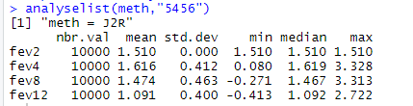

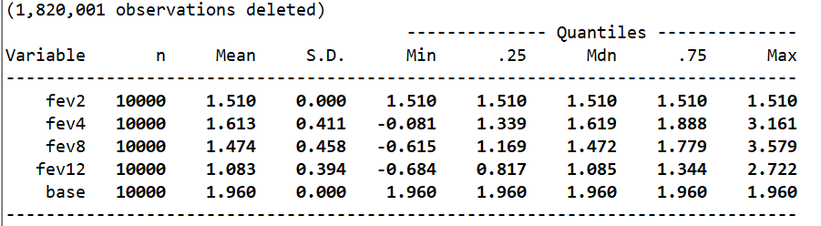

pttestf(10000,10000,1.083,0.394,1.091,0.4)

[1] 0.07710669

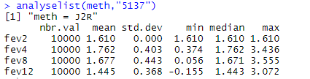

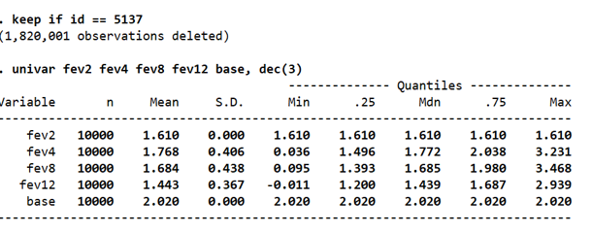

pttestf(10000,10000,1.677,0.443,1.684,0.438)

[1] 0.130588

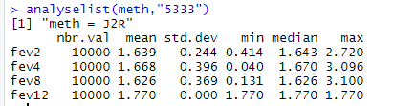

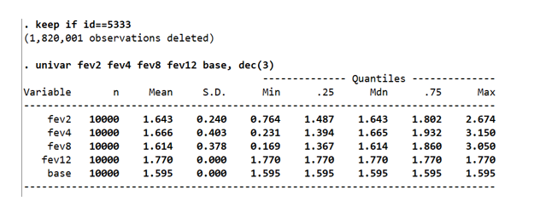

pttestf(10000,10000,1.614,0.378,1.626,0.369)

[1] 0.01155869

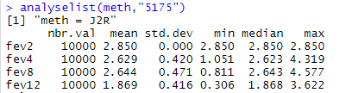

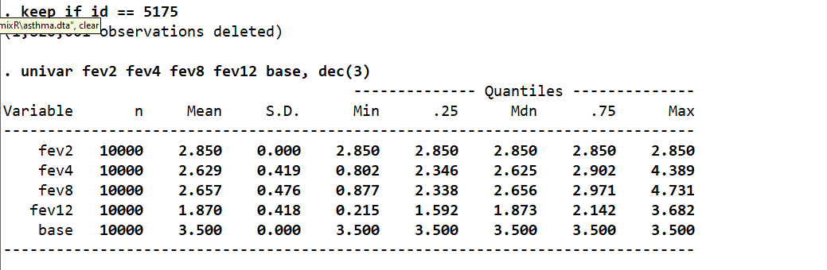

pttestf(10000,10000,2.644,0.471,2.657,0.476)

[1] 0.02611535

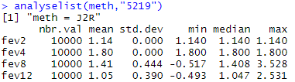

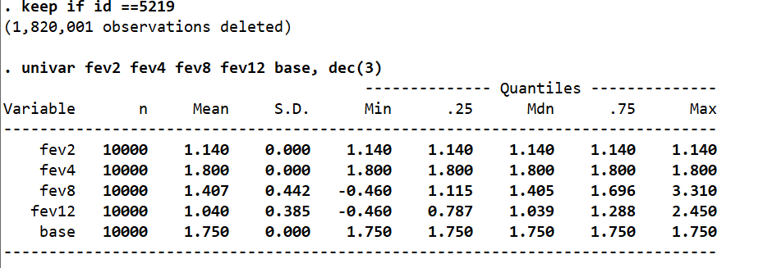

**regression coefficient** outputs and se’s with different dependent vars

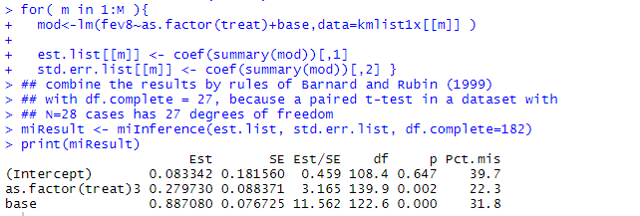

Figure fev12~

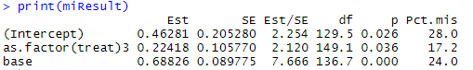

## LMCF

Figure mimix fev treat, id(id) time(time) method(lmcf) refgroup(2) covariates(base) clear m(1000) seed(101)

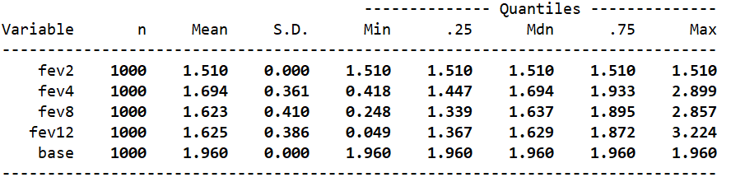

Figure 4 kmargs <- list("fev","treat","id","time","base",10000,2,"LMCF",201)

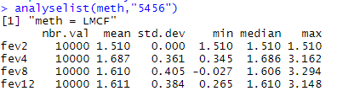

## Accupuncture Data

Figure mimix head treat, id(id) time(time) covariates(head_base) method(j2r) refgroup(1) m(1000) clear

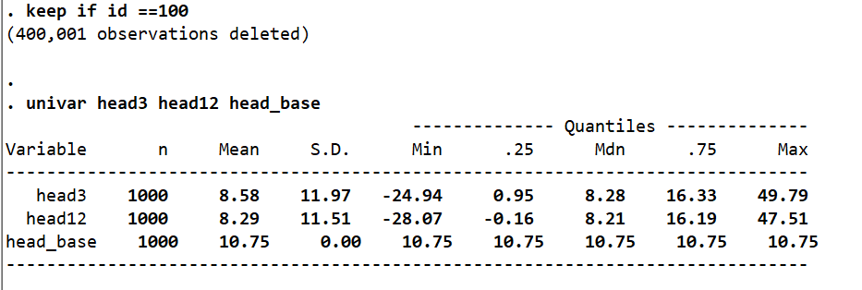

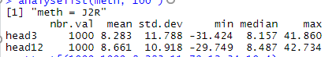

pttestf(1000,1000,8.283,11.79,8.58,11.97)

[1] 0.2881119

